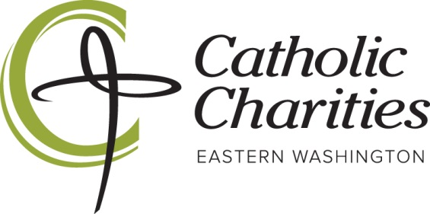

**Junior Board Application for 2025-2026 School Year**

**Our Mission:**

**Feed the Hungry. Heal the Hurting. Welcome the Stranger.**

We strive to strengthen the capacities and influence of our Catholic Charities Eastern Washington mission by engaging a younger, mission-minded, heart-for-service leadership team, so that together we may pursue our vision of a more compassionate, respectful, collaborative, and justice-filled community.

**Our Vision- A Heart for Service**

Our Junior Board is comprised of young individuals who are ready to jump into action at all levels in our mission to serve. These young men and women will serve as our CCEW representatives in all facets of our service, whether volunteering, assisting with events, meeting & greeting, praying, sitting at the table at CCEW Board meetings, or launching new and creative initiatives. This will always be done with guidance from a CCEW team member. This is not just for Catholic youth, but a city-wide all-inclusive, service-minded team.

We want each individual CCEW Junior Board member to leave positively changed and impacted by their involvement and their work within our programs to serve the poor and vulnerable.

**To serve on the Junior Board you must:**

• Be a Freshman, Sophomore, Junior, or Senior enrolled in high school for the 2025-2026 school year

• Be in good academic and disciplinary standing at your school (3.0 GPA or higher)

• Attend a high school within Spokane County

• **Be available for monthly in-person meetings for EITHER the Fall or Spring terms or BOTH**

* + Option 1: Fall Term - Serve September - December 2025
  + Option 2: Spring Term - Serve January - May 2026
  + Option 3: Full Year - Serve September 2025 – May 2026

• **Commit to at least 3 service opportunities per term**

* + Required to receive a certificate of participation and any letter of recommendation from the Junior Board supervisors.

**Submit a volunteer application on our website; please indicate “Junior Board” when prompted** [www.cceasternwa.org/applynow](http://www.cceasternwa.org/applynow)

**Finally, to submit your Junior Board application please complete the following pages and email to volunteering@cceasternwa.org by September 15, 2025.**

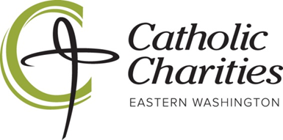

**2025-2026 Catholic Charities Junior Board Application**

Name: _____________________________________________­­­­_________________________________________________

Last MI First

Preferred Nickname (if applicable): _________________________

Date of Birth: __________________________

mm/dd/yyyy

Mailing Address: ___________________________________________________________________________________

Street City State Zip

Cell Phone: _______________________________ Email: ____________________________________________________

Emergency Contact/Relationship: _____________________________________________________________________

Emergency Contact Cell Phone: _________________________

School name**: ______________________________________** Year in School (for ’25-26): ______________________________

Extracurricular Activities (sports, clubs, etc.): **___________________________________________________**

**__________________________________________________________________________________________________________________**

**I am interested in serving on the Catholic Charities Junior Board for the following term (check one):**

**______ Fall Term: September – December 2025**

**______ Spring Term: January – May 2026**

**______ Full Year: September 2025 - May 2026**

**More About You…**

***Our Mission Statement****: Feed the Hungry. Heal the Hurting. Welcome the Stranger.*

1. **What does the mission of the Catholic Charities mean to you (see above)?**
2. **Why are you interested in serving as a member of the Catholic Charities Junior Board?**

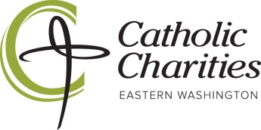

**STUDENT VOLUNTEER PROGRAM  
PARENTAL ACKNOWLEDGEMENT/PERMISSION FORM**

*(Along with the volunteer application, this form is required for all high school students)*

I give permission for __________________________________(Name of Student) to work as a volunteer for Catholic Charities Eastern Washington in the Catholic Charities Junior Board Program._

I am aware that he/she will be working as a volunteer at this program. I understand that he/she is registered as a volunteer covered by supplemental insurance and will be provided a short orientation prior to beginning volunteer work. To the best of my knowledge, he/she has not been convicted of any crimes against persons or property.

I, my personal representatives, heirs and assigns do hereby agree to protect, defend, hold harmless and fully indemnify Catholic Charities Spokane, its programs, agents, officers, employees, insurers, and assigns, for any claim or cause of action arising out of strict liability or ordinary negligence in any way connected with my child’s volunteer activity which causes my child physical harm or property damage. I further agree to release, hold harmless and indemnify Catholic Charities Spokane, its programs, agents, officers, employees, insurers, and assigns, from any claim, judgment or expenses which may be incurred by my child’s participation in said activity.

__________________________­­­__________ _______ _________________________________  
Signature of Student Volunteer Age Date of Birth

__________________________­­­­­­­­­__________ _____________________________ ___________­­­___  
Name of Parent/Guardian (please print) Signature of Parent/Guardian Date

** A PHOTOCOPY OF YOUR CURRENT DRIVER’S LICENSE OR STUDENT ID CARD MUST**

**ACCOMPANY THIS APPLICATION.**

***Thank you for your application! We will contact you by email to let you know if you have been selected.***

**Please mail the completed application and copy of ID to:**

Catholic Charities Eastern Washington

Attn: Junior Board

PO BOX 2253

Spokane, WA 99210-2253

**OR email a scanned copy to volunteering@cceasternwa.org**