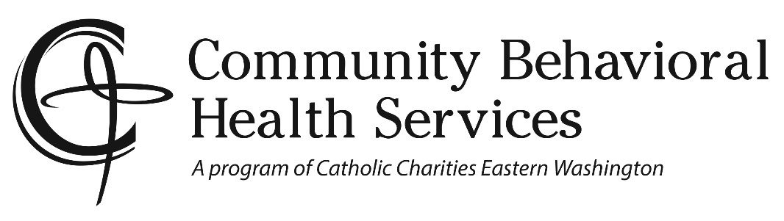
Client copy

Tobacco Quitline Phone Numbers
Many insurance plans use the Washington State Quitline for tobacco cessation services. Some plans may use other quit lines or wellness plans. Refer to the tables below to find a phone number to call based on your medical/wellness plan.
Medicaid Plans (Apple Health)
Plan Name Counseling Type Quitline Number
Alien Emergency Medical One call 1-800-QUIT-NOW
Amerigroup Washington Multi-call 1-800-QUIT-NOW
Apple Health Fee-for-Service Multi-call 1-800-QUIT-NOW
Community Health Plan of Washington Multi-call 1-800-QUIT-NOW
Coordinated Care Corporation Multi-call 1-866-274-5791 ext. 6
Family Planning Only One call 1-800-QUIT-NOW
Molina Healthcare of Washington Multi-call 1-800-QUIT-NOW
Take Charge One call 1-800-QUIT-NOW
United Health Care Community Plan Multi-call 1-800-QUIT-NOW
Other Plans
For plans not listed, please check your plan coverage.
If you are uninsured or have a health plan with no benefit to help you quit tobacco, you can call the Washington State Quitline at 1-800-QUIT-NOW. The quit line will help you with your quit attempt.
2Morrow Health smartphone app: All Washington State residents have free access to a full cessation program delivered via an easy-to-use smartphone application shown to help people quit in multiple clinical trials. Participants sign up at doh.wa.gov/quit and complete a short anonymous survey to gain free access.

