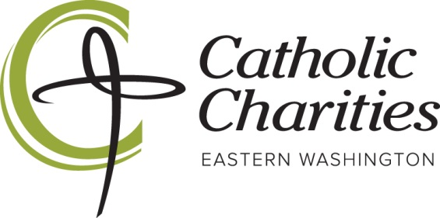
Junior Board Application for 2021-2022 School Year

Our Mission

To strengthen the capacities and influence of our Catholic Charities Eastern Washington mission by engaging a younger, mission-minded, heart for service leadership team, so that together we may pursue our vision of a more compassionate, respectful, collaborative and justice-filled community.

Our Vision- A Heart for Service

Our CC JR Board is comprised of young individuals who are ready to jump into action at all levels in our mission to serve. These young men and women will serve as our CCEW representatives in all facets of our service, whether volunteering, assisting with events, meeting & greeting, praying, sitting at the table at CCEW Board meetings, or launching new and creative initiatives. This will always be done with the guidance from a CCEW team member. This is not just for Catholic youth, but a city-wide all inclusive, service minded team.

Our Board is not just for college applications– but for a lifetime. We want each individual CCEW Jr. Board member to leave positively changed and impacted by their involvement on our CCEW Board and their work within our programs to serve the poor and vulnerable.

To serve on the Junior Board you must:

• Be a Freshman, Sophomore, Junior or Senior for the 2021-2022 school year
• Be in good academic and discipline standing at your school (3.0 GPA or higher)
• Attend a high school within Spokane County
• Be available for monthly in-person meetings
  - First Tuesday of each month starting Tuesday, October 5th from 6-7pm
• Commit to at least 6 service opportunities and participate in the annual service project
  - Required to receive a letter of recommendation from supervisor.

To Submit your Junior Board application please complete the following pages and email to Sierra Heinen at sierra.heinen@cceasternwa.org by September 16th, 2021.
If you are accepted, a full volunteer application will be required: www.cceasternwa.org/applynow

2021-2022 Catholic Charities Junior Board Application

Name:______________________________________________________________________________________________
Last MI First

Date of Birth: __________________________ Email ____________________________________________________
mm/dd/yyyy

Mailing Address:___________________________________________________________________________________
Street City State Zip

Home Phone:_______________________________ Cell Phone:___________________________________

Emergency Contact/Relationship:____________________________________Phone#_________________________

School name: ______________________________________ Year in School: ______________________________

__________________________________________________________________________________________

I am fully vaccinated against COVID-19: ________ yes _________ no
*Note: we require all volunteers to be fully vaccinated against COVID-19 prior to
working in direct contact with clients and staff. If you are not fully vaccinated your volunteer opportunities may be limited.

More About You

- What is your personal philosophy regarding community service?

- Please list any previous volunteer experience. If you have never volunteered, share your personal goals for volunteer service:

- If selected, how would you “live” the mission of the Catholic Charities Junior Board and that of Catholic Charities Spokane? (See attached).

- What are your extracurricular commitments for the coming school year?

- If you could have the ability to fly or be invisible which would you chose and why?

- If you were given $10,000,000 today what are the first 3 things you would do?

- What motivates you to jump out of bed in the morning?

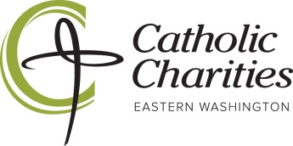
STUDENT VOLUNTEER PROGRAM
PARENTAL ACKNOWLEDGEMENT/PERMISSION FORM
(Along with the volunteer application, this form is required for all high school students ages 16 and 17.)

I give permission for __________________________________(Name of Student) to work as a volunteer for Catholic Charities Eastern Washington in the Catholic Charities Junior Board Program._
I am aware that he/she will be working as a volunteer at this program. I understand that he/she is registered as a volunteer covered by supplemental insurance and will be provided a short orientation prior to beginning volunteer work. To the best of my knowledge, he/she has not been convicted of any crimes against persons or property.
I, my personal representatives, heirs and assigns do hereby agree to protect, defend, hold harmless and fully indemnify Catholic Charities Spokane, its programs, agents, officers, employees, insurers, and assigns, for any claim or cause of action arising out of strict liability or ordinary negligence in any way connected with my child’s volunteer activity which causes my child physical harm or property damage. I further agree to release, hold harmless and indemnify Catholic Charities Spokane, its programs, agents, officers, employees, insurers, and assigns, from any claim, judgment or expenses which may be incurred by my child’s participation in said activity.

____________________________________ _______ _________________________________
Signature of Student Volunteer Age Date of Birth

____________________________________ _____________________________ ______________
Name of Parent/Guardian (please print) Signature of Parent/Guardian Date

 A PHOTOCOPY OF YOUR CURRENT DRIVER’S LICENSE OR I.D. CARD MUST
ACCOMPANY THIS APPLICATION.

Thank you for your application! We will contact you by email to let you know if you have been selected.

Please mail completed application and copy of i.d. to:

Catholic Charities Eastern Washington
Attn: Sierra Heinen, Community Relations Manager
12 E. 5th Ave, PO BOX 2253 Spokane, WA, 99210-2253

OR email a scanned copy to volunteer@cceasternwa.org

CCEW Volunteer Health Waiver
In return for being allowed to participate in Catholic Charities of Spokane's volunteer activities (“Volunteer Activities”), I, as "the Volunteer" (or a Parent/Legal Guardian if the Volunteer is under age 18), releases and agrees not to sue Catholic Charities of Spokane or its officers, directors, employees, sub-contractors, sponsors, agents and affiliates (“Catholic Charities”) for any reason (whether now or in the future) for any property damage, personal injury, or wrongful death arising as a result of my participation in the Volunteer Activities.
I acknowledge that participation in the Volunteer Activities may place me in proximity to contagious illnesses, including but not limited to influenza, hepatitis, and COVID 19. I agree to comply with all State and Federal guidance and recommendations regarding personal hygiene and other steps to avoid and/or lessen the spread of contagious disease. I further acknowledge that the risk of contagion cannot be eliminated or fully mitigated. I choose to participate in the Volunteer Activities despite the risk of my contracting a contagious illness.
I understand and agree that Catholic Charities is not responsible for any injury or property damage arising out of the Volunteer Activities, even if caused by Catholic Charities' negligence or otherwise. I understand that participation in the Volunteer Activities involves risks, including but not limited to those described herein. I am voluntarily participating in the Volunteer Activities with knowledge of the danger involved and I agree to accept all risks of participation.
I also agree to indemnify and hold Catholic Charities harmless from and against all claims arising out of my participation in the Volunteer Activities. I also acknowledge that Catholic Charities has not arranged and does not carry any insurance of any kind for my benefit or that of the Volunteer (if the Volunteer is under 18), my parents, guardians, trustees, heirs, executors, administrators, successors and assigns. I understand that this document is intended to be broad and inclusive as permitted by State and Federal law.
I represent that, to my knowledge, I am in good health and suffer no physical impairment that would or should prevent my participation in Volunteer Activities, including but not limited to a susceptibility to contagious disease.
I am of legal age and am freely signing this agreement. I have read this form, and understand that by signing this form, I am giving up legal rights and remedies.
Signed this ___ day of _______, 2021, at Spokane, Washington.
________________________
NAME, Volunteer
If under 18:
I am the parent or legal guardian of the Volunteer. I am of legal age and am freely signing this agreement. I have read this form and understand that by signing this form, I am giving up legal rights and remedies.
Signed this ___ day of _______, 2021, at Spokane, Washington.
____________________________
NAME, Parent of Volunteer NAME

