Client copy
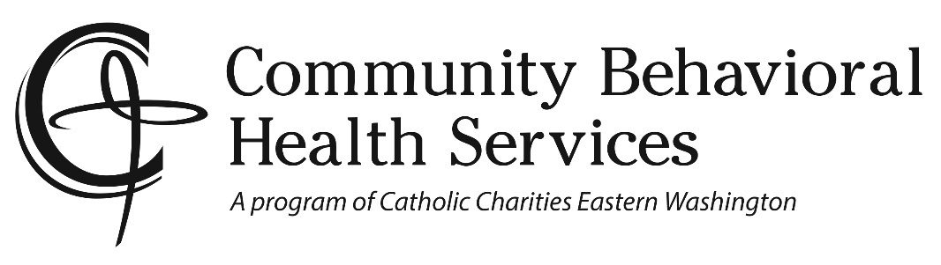

Physician Referral List for Medicaid
- Rockwood Clinic 509-838-2531
- CHAS Clinic 509-444-8200 (Also provides dental care)
- Providence Health Care 509-252-9602
- Unify Community Health 509-326-4343 (Also provides dental care)
- Kaiser Permanente (Molina only) 509-688-6700
- Spokane Teaching Health Clinic 509-626-9900

Problem Gambling Resources:
New Horizon Care Centers
701 E 3rd Avenue
Spokane, WA 99202

PSYCHIATRIST PRESCRIBER RESOURCES
- Excelsior
509-559-3100
- Frontier Behavioral Health
509-838-4651
- Spokane Teaching Clinic
509-626-9900
- Chris Korsgaard, ARNP
509-389-5794
- Nicholas Goodwin, DNP, PMHNP
509-415-3507

